Project 2

Original / Greyscale

To convert to greyscale I converted the RGB values to YUV and then made U and V = 0 then converted back to RGB and displayed the image.

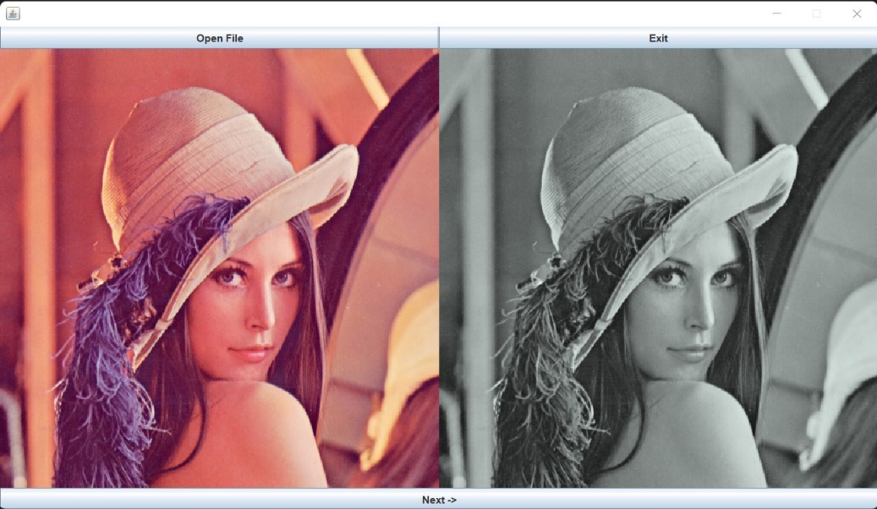

Greyscale / Dithering

I used an 8x8 dither matrix found at [Ordered dithering - Wikipedia](https://en.wikipedia.org/wiki/Ordered_dithering). Found the relation between the Y value from the greyscale image and the dither matrix by converting each Y within the dither matrix bounds Formula: Y/(255 / ( (ditherMatrix.length ^ 2) – 1 ). I found that the 8x8 dither matrix provided more details than a 4x4 or a 2x2, because of this I have submitted using an 8x8.

Original / Auto Levels

My implementation of auto levels finds the count of each value between 0-255 of each of R, G, and B. Using this count it finds if the values are less than the 10th percentile or greater than the 90th percentile. Then it finds the max and min within 10th and 90th percentiles and any outliers are converted to the max or min (whichever is closer). Then for each R, G, and B values I made the lowest value = 0 and transformed each other pixel by making it equal to (Value – min) * (255 / (max – min)).

